1)

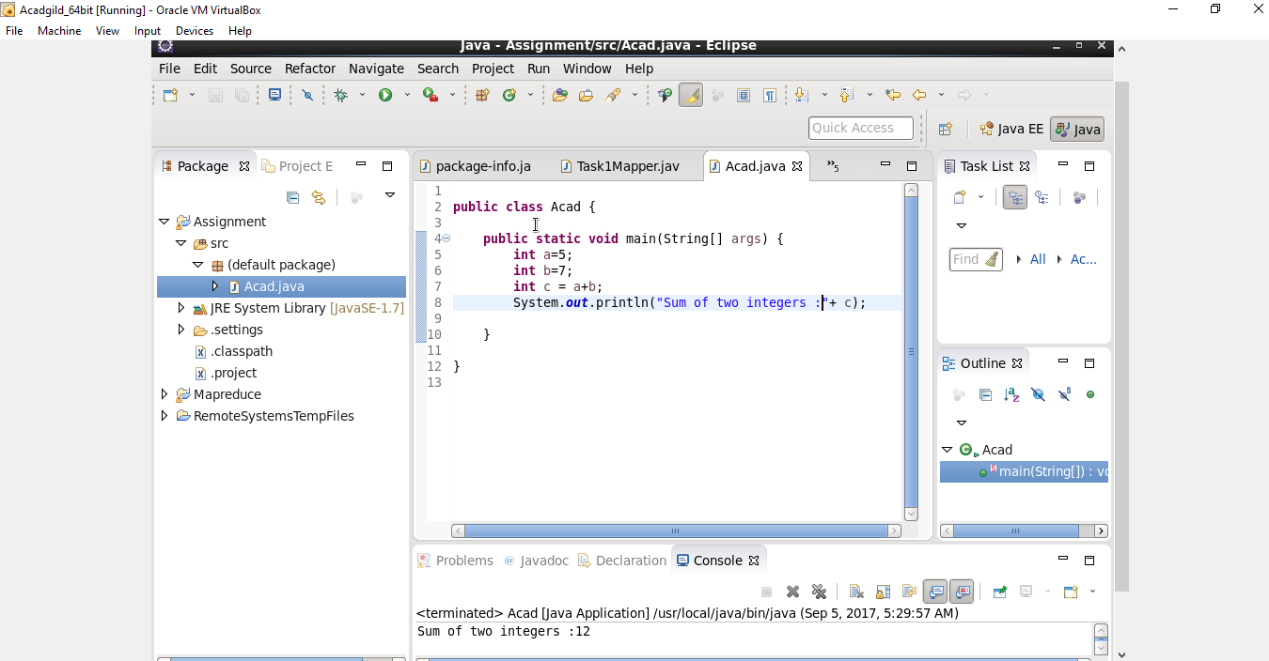

2)

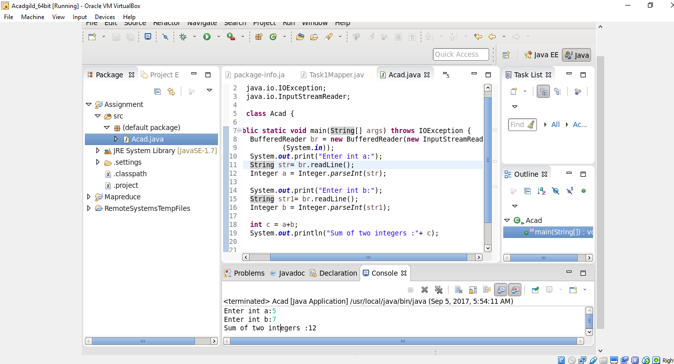

3)

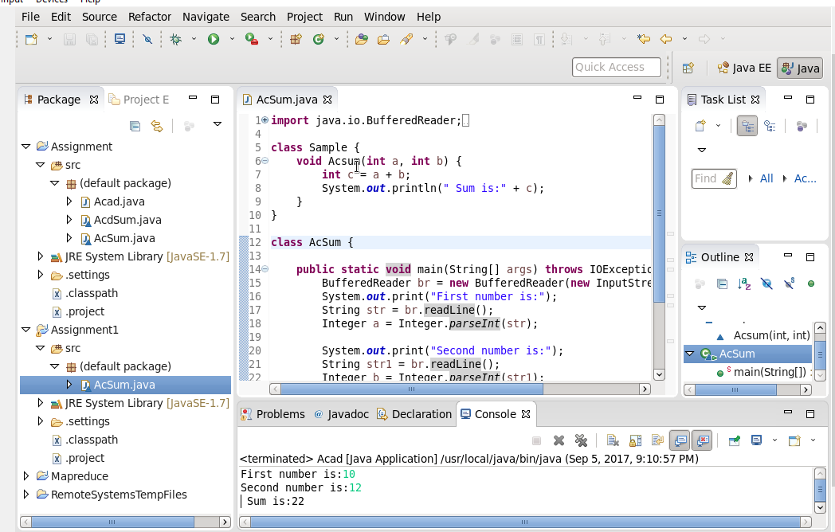

4)

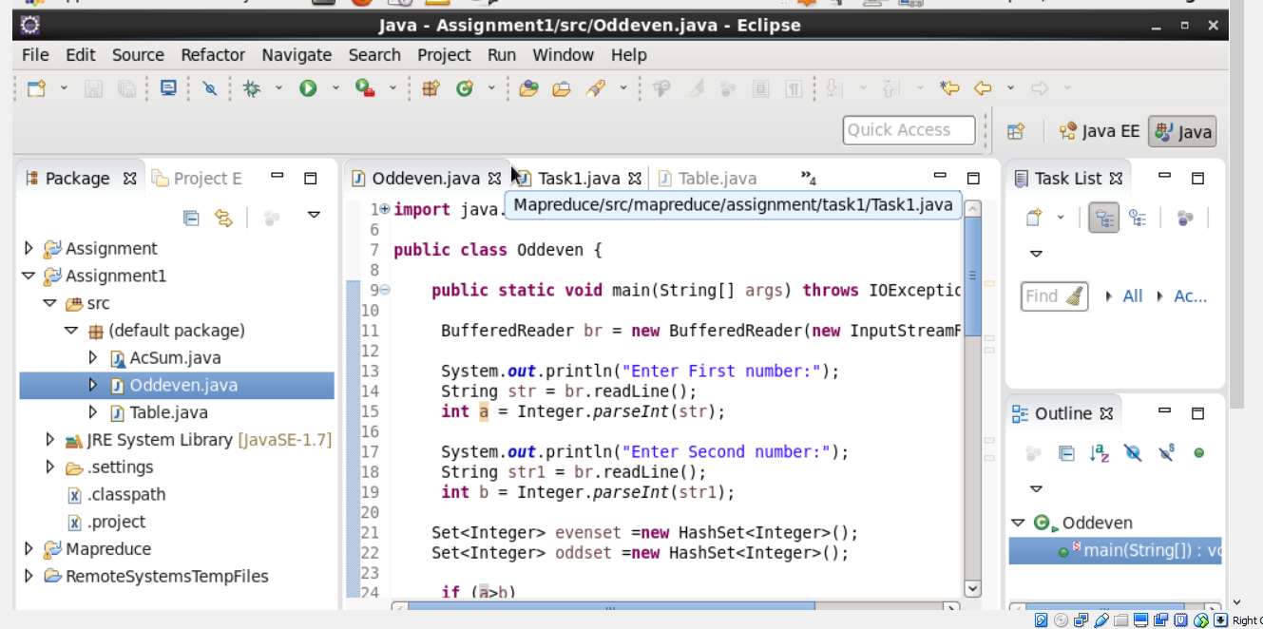

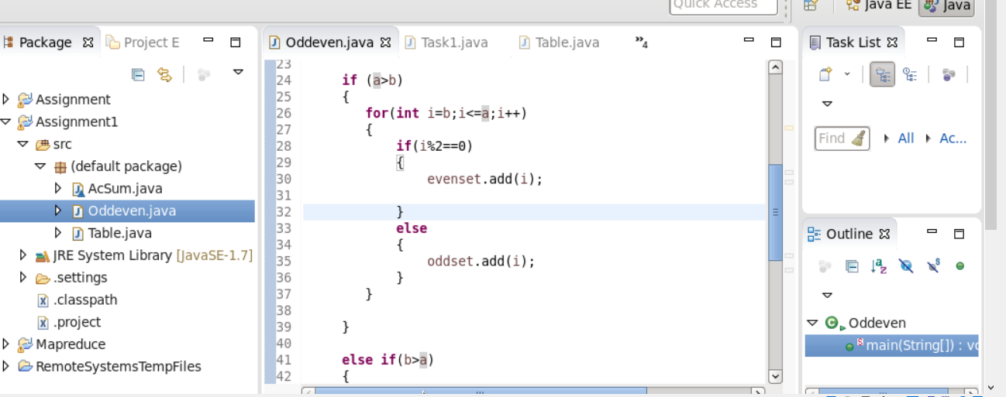

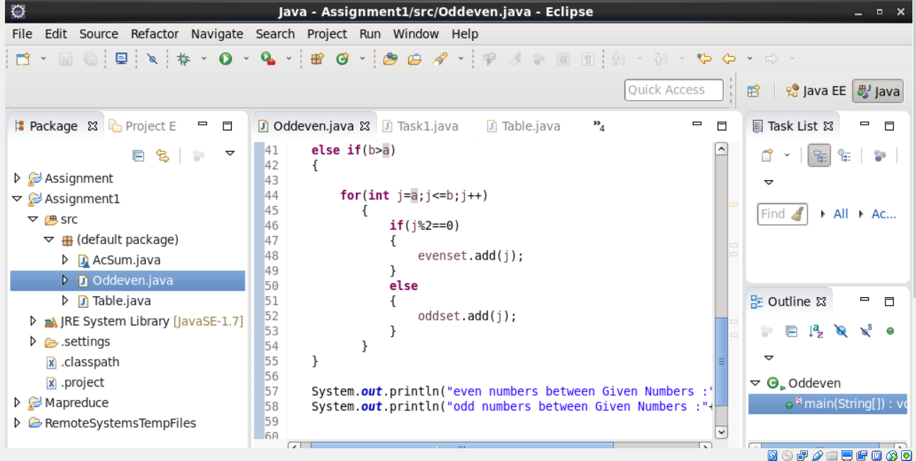

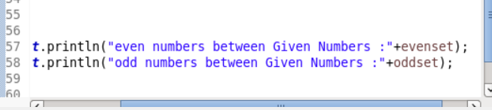

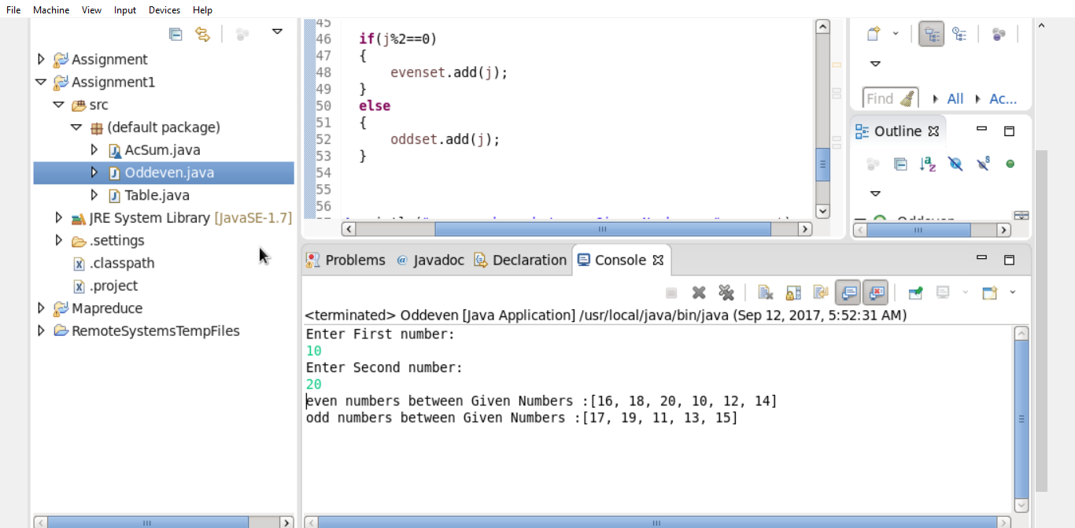

6)

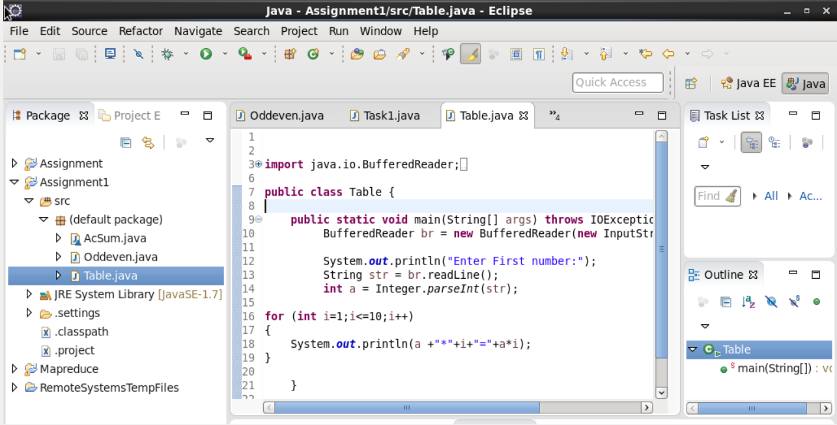

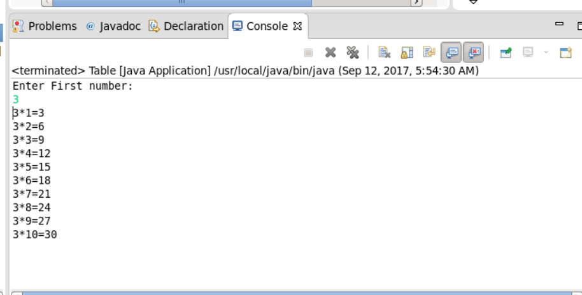

6) Overloading:-

If a class has multiple methods having same name but different in parameters, it is known as **Method Overloading**.

If we have to perform only one operation, having same name of the methods increases the readability of the program.

There are two ways to overload the method in java

1. By changing number of arguments
2. By changing the data type

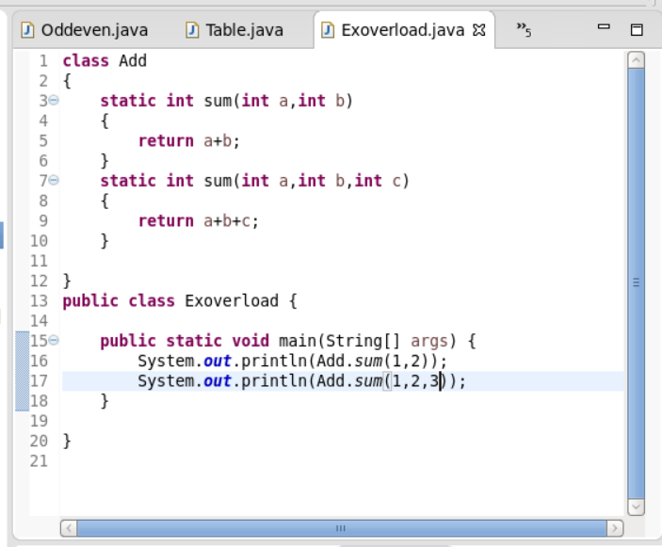

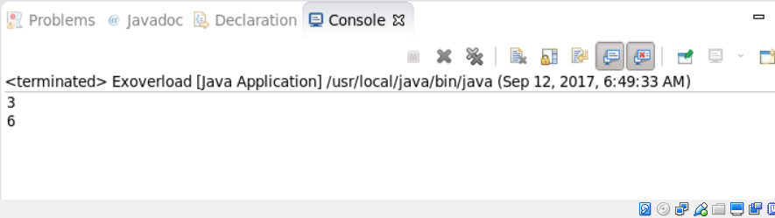

7)

In java, method overloading is not possible by changing the return type of the method only because of ambiguity.

Method overloading is possible with same return type.

|  |  |
| --- | --- |
|  | Method Overloading means to have two or more methods with same name in the same class with different arguments. The benefit of method overloading is that it allows you to implement methods that support the same semantic operation but differ by argument number or type.  Important Points   * Overloaded methods MUST change the argument list * Overloaded methods CAN change the return type * Overloaded methods CAN change the access modifier * Overloaded methods CAN declare new or broader checked exceptions * A method can be overloaded in the same class or in a subclass |
|  |  |

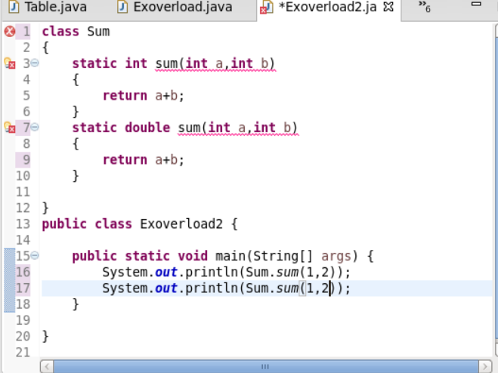

Compile time error : Duplicate method sum.

In the above example 6: method overloading done by same return type.

8)

